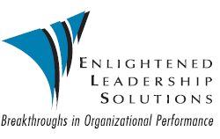

Ed Oakley Pre-Program Questionnaire
Denver, Colorado

Group Name:

Date of Event:

All questions may not apply to your group, so please fill out what is appropriate.

- What is your conference theme?

- What are your specific objectives for the Ed’s presentation?

- What are sensitive issues that should be avoided?

- Time frame of presentation:

Approximately from am/pm to am/pm

- What takes place immediately before and after the Ed’s presentation?

- Who are other speakers on the program (if any)?

- What professional speakers have you used in the past?

- What did you like/dislike about their performance?
(list what you remember the most and if you’d like to delete or repeat for your audience)

- How many audience members do you anticipate?

- Is this a specialized group or general public?
If specialized, please explain details.

- Please list (3) items you believe the Ed should know before addressing your group:

1.

2.

3.

- What are the most significant events that have occurred in your industry, organization, school, and/or group this year?

- Audience demographics:
Size:

Percentage of men: %

Percentage of women: %

Spouses: yes no

Average age of group?

Average income of group $

General description of attendees:

- What is your goal for your audience? (the most important question)

- Please provide a brief description of your organization:

